A Basic Guide to Single-Particle Data Collection on the Titan Krios
General Information
- The Beckman Center for Cryo-EM at Johns Hopkins is in Rangos G36
- The phone number for the suite is 410-955-3750
  - If you need to dial out of the room, press 9-1 before the number.
- If you need assistance at any time, please contact Duncan Sousa over email or Teams.
- If an oxygen alarm is going off, evacuate the room immediately and call safety.
- Restrooms are past the corridor double doors on the way back to the lobby (Men’s code 1234*, Women’s code 4321*).
Data Collection Overview
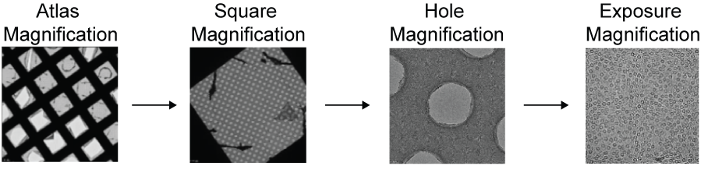
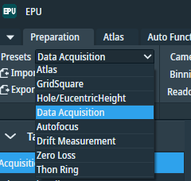
Your high resolution micrographs are collected from high-magnification micrographs or exposures taken in holes. To achieve this in a high throughput and automated fashion, we need to first image the entire grid at low magnification to generate an atlas of the grid. After this, we take slightly higher magnification of images of squares, to assess ice behavior within the squares and identify holes. Following this, we take medium magnification images of the holes. This will allow us to precisely locate the areas we want to take our high-magnification exposures. These magnifications are saved in EPU presets.
Before you get started:
- What is the hole size and hole spacing in your grids?
- What is the mesh size of your grid?
- What magnification do you want to use for exposure?
- These details will dictate what presets we import.
Exposure Magnification | Pixel Size (Å/pixel)
230,000x (230kx) | 0.47
215,000x (215kx) | 0.5655 (ApoF)
165,000x (165kx) | 0.76
130,000x (130kx) | 0.97
  - The presets are magnifications specific to each type of grid and the sample. The exposure magnification is a critical factor for your data collection. The theoretical resolution limit of your reconstructions will be limited to twice your pixel size. This is the Nyquist limit.

  - Import from: Desktop/Desktop/EPU/215kx_300_1_2-1_3.sxml (for example)
    - 215kx = exposure magnification

    - 300 = mesh size
    - 1_2 = hole size
    - 1_3 = hole spacing
During this protocol, record the following and ask for help if there are major deviations in: room temperature and humidity, changes in ZLP tuning parameters, FEG emission, nitrogen levels (autoloader/column in software, dewar probes).
Loading the Microscope
Clipping
- Have ready: bone-dry clipping tools with C-clips loaded (load C-clips using blunt tweezers), fine tweezer for grid handling, autogrid tweezer for finished autogrids, coin or tweezer-back to turn clipping station brass disk, grid boxes, clip rings, 1-2 4L dewar of LN2, hair dryer or dehydrator oven
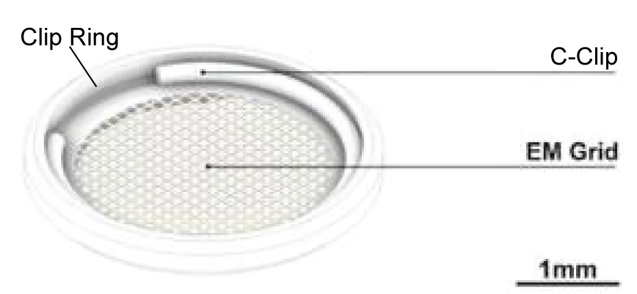
- Cool clipping station – LN2 should go up to top of brass disk
- Place boxes and cool as many clip rings as you’ll need
- Clipping process – learn this in person
  - Grids should face foil-side or carbon-side down, and the C-clip will touch the back side of grid (the mesh). This protects the foil/sample side from the C-clip and helps optimize the eucentric height.
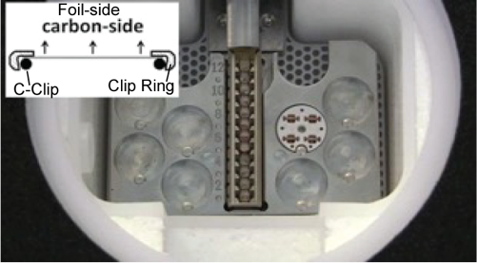
Loading grids into the cassette
- Make sure that you grip the whole autogrid, not just the edge, when inserting it into the cassette.
- Lightly tap the grid when loaded to make sure that it is at the bottom of the cassette and secured.
- C-clip side should face the NanoCab of the cassette in the loading station). The flat cartridge / carbon side should face the cassette grip (has a handle) side of the loading station. See figure above.
- Leave slot 1 empty for the cross-grating that will be on the stage.

Loading cassette into the microscope
- Make sure there are no active errors and that all temperatures are in green status.
- After NanoCab docking, wait for Cartridge Gripper to be colder than -175 °C.
- Click Inventory to let autoloader find the grids, do not manually edit slot state.
- If desired, type in labels and they will carry over to EPU’s Atlas list when an Atlas session is created later
- There will already be a cross-grating grid on the stage, keep it there for Align Energy Filter and Direct Alignments, that is, don’t load one of your grids to the stage yet.
  - In Stage², two positions are saved.
    - An align position
    - An empty area
  - Please do not delete these areas.
- Turbo should be set to Auto Off after loading. It will automatically switch to Always On during Atlases.
Align Energy Filter (collect with a 10 eV slit)
- Use EPU to go to empty (broken) grid square
  - Open EPU and in Preparation tab import appropriate Presets (an sxml file from Desktop > Desktop > EPU)
  - Select Atlas magnification and click Preview, right-click and move to open area with right-click menu > “Move stage to here” (if don’t see one yet, use “Move stage to here” to look around).
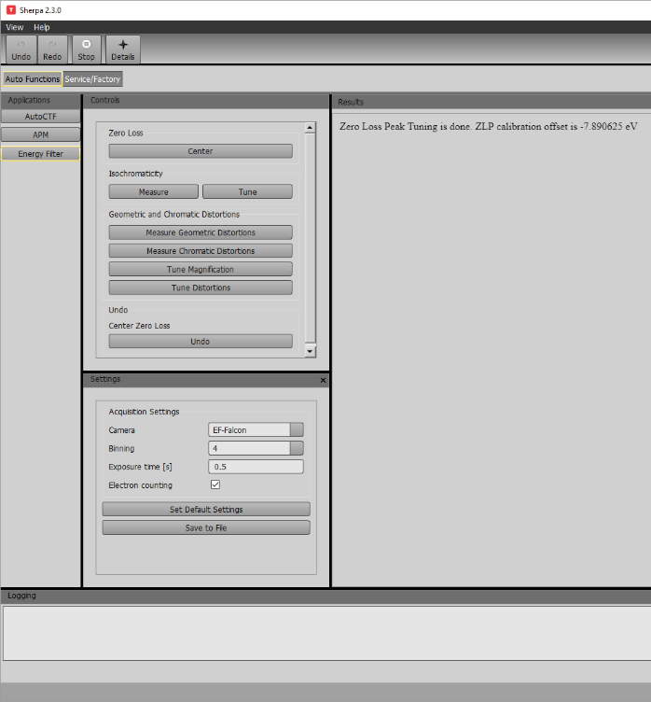
  - Select Data Acquisition and click Set, insert Flu Screen to make sure beam is centered on green circle (energy filter aperture), then retract screen.

  - NOTE do not use track ball to center the beam, use Direct Alignment beam shift
- Open Sherpa and go to Energy Filter section
- Click Center under Zero Loss heading. When it is finished, expect to see an absolute value of the calibration offset ~0.5 +/- 0.2.
- Click Measure under Isochromaticity heading. Click Tune if it’s outside the indicated spec of 1.00.
- Click Measure Geometric Distortions. Click Tune Magnification if it’s outside spec of 0.50%.
  - If Geometric Distortion is severe (unlikely), Tune Magnification may not fully resolve the issue and the tuning will be completed in the Chromatic Distortions step below.
- Click Measure Chromatic Distortions. Click Tune Distortions if it’s outside spec. Max distortion spec should indicate 0.50%. Max chromatic distortion should indicate 0.40%.
- Go back to unbroken grid square by using the Atlas preset in EPU and clicking “move stage here” on unbroken grid square.
Direct Alignments
CRITICAL – do not do these without training. If you need assistance, please contact Duncan Sousa.
Note – be in Data Acquisition magnification, except when doing Eucentric Height
These will use the Flu Screen unless use of EPU Auto Functions or Sherpa is specified. The Falcon camera is only used in the EPU and Sherpa environments. The Falcon camera is only used in the EPU and Sherpa environments not the Flu Screen environment. Before each procedure, make sure to click Set in EPU to set the preset/microscope back to its Data Acquisition intensity.
- Press Eucentric Focus on control pad
- Center C2 Aperture
  - Turn on TwoLens (under the filter tab).
  - Adjust intensity so that you can see the beam increasing and decreasing in diameter and make sure it stays centered as it spreads (draw circles on Flu Screen if that helps).
  - If it is no longer centered when spread wide, open Apertures panel, click Adjust for C2 Aperture, and use the MF knobs to adjust it.
  - When done, deactivate Adjust button and press Set in EPU in case any microscope parameter was changed in the TEM user interface.
  - Turn the system back to TEM (under the filter tab).
  - Send Data Acquisition to the scope to bring back all the other settings.
- Condenser Center TEM (align C3 to C2) - Check for centered spreading at the intensity threshold where the C3 kicks on, and if necessary, adjust using Direct Alignments Condenser Center TEM then click Done.
- Beam Shift – Determine if beam is centered around green circle (the energy filter aperture). If it is not, use Beam Shift Direct Alignments to adjust then click Done.
- Eucentric height
  - Turn the autoloader turbo off
  - EPU > Auto Functions tab > Auto eucentric by beam tilt Task, and choose Hole/Eucentric Preset > Start
    - If it fails, try Auto eucentric by stage tilt, and choose Gridsquare mag
    - If it still fails, try manually with the Flu Screen and Stage Wobbler
  - Change back to Data Acquisition when finished and insert the screen again.
  - 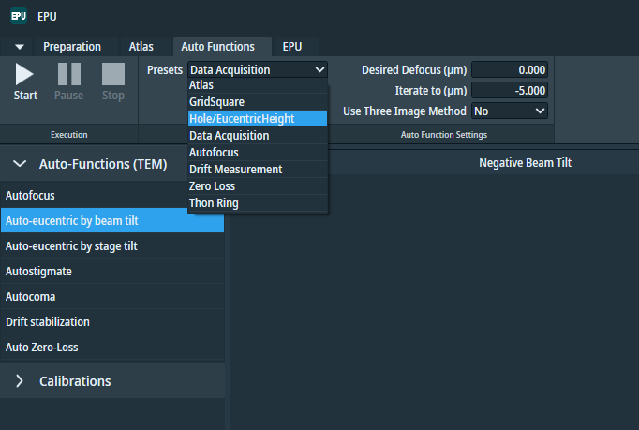
- Condenser astigmatism - Insert screen again before proceeding with condenser astigmatism. Change the intensity using the knob and make sure the beam is round. If it is not round, open Stigmator panel, click Condenser, and adjust stigmation using MF knobs, then click None to leave the condenser adjustment mode.
- Calibrate zero focus
  - Manually turn focus to -1.5 microns
    - Click eucentric focus, then R2 (reset defocus). Then manually change focus to -1.5 um. Change focus step with outer ring of manual control to get finer defocus step size, then use the inner focus knob to change defocus to -1.5 um.
  - Sherpa > AutoCTF, bin 2 (to avoid gold diffraction ring) > Objective Stigmation > Measure
    - If off >> 0.5, could be problem with Z height. Redo auto eucentric height function.
  - Take difference between the calculated defocus and the nominal defocus you set (-1.5).
  - Manually, change focus with the knob to account for the difference, then reset it to zero (R2 on pad).
  - Now set back to -1.5, and measure again. Check how well you did.
  - Manually turn focus back to zero (can’t use Eucentric Focus button for this, it’s now a different zero).
  - 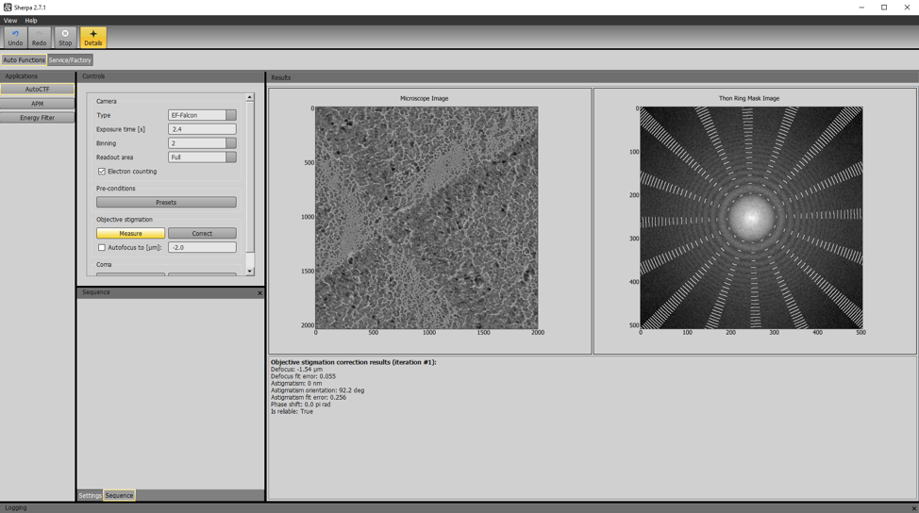

- Beam tilt pivot points – Direct Alignments and click Done.
  - Remember to insert screen again and click Set in EPU. Do the nP (nanoprobe) Pp X and Y, not the Coma pivot points. Also, try to make the adjustments with MF X knob not MF Y.
- Rotation Center – Direct Alignments and click Done, but if this looks good, just skip without turning knobs. If the image (not the beam edge) is moving around, adjust until as stationary as possible.
- Center objective aperture – Apertures panel, but only if you plan to use the aperture
  - Note, this process uses diffraction mode, be completely sure Flu Screen is inserted
- Objective astigmatism and Coma
  - Make sure to Set the Data Acquisition Preset again before preceeding
  - Manually turn defocus to –1.5 um
  - Sherpa > AutoCTF, bin 2, exp 2s > Objective Astigmatism > Correct
    - It will say Objective Astigmatism Correction finished after a minute or two
  - Coma > Correct
  - Then repeat Objective Astigmatism > Correct
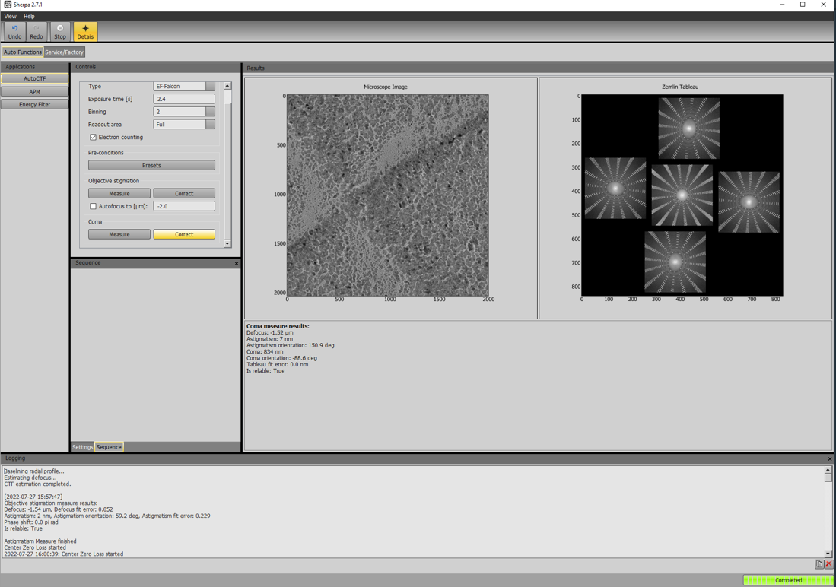
- Beam shift – Insert screen, set Data Acquisition Preset to scope. Beam shift may need final correction after Coma correction, use Direct Alignments again.
- Click Inventory to let autoloader find the grids if it hasn’t been done yet (do not manually edit slot state).
- Turn the autoloader turbo off.

Dose Check
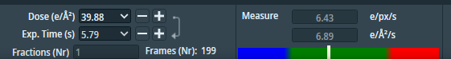
- Go to an empty area.
- Make sure Data Acquisition mag is set to the scope and the desired dose is 40 e⁻/Å², then click Measure.
- Anywhere in the green is fine. 5 to 7 e⁻/px/s is optimal for the highest resolution.
- Confirm that the measurement is around the middle of the central, green region of the meter. Lower is better for less coincidence loss.
- Record the measurement values and the exposure time in your own notes.
- There are more details in Thermo’s EPU user manual on page 30.
- Keep the scope set to Data Acquisition and the empty area location in place for the gain reference process below.
Collect a Gain Reference
- Use Data Acquisition over an empty area.
- Click the Falcon-4(i) Reference Image Manager icon that is pinned to the Task Bar. If this icon is missing, find the program shortcut in Desktop > Titan Tools.
- Insert Flu Screen and check that the beam illuminates the entire energy filter aperture and is centered, then retract the Flu Screen.
- In the Reference Image Manager, click Measure Dose. The dose rate should be within the green range of the intensity indicator and match the value measured earlier in EPU (around the 6 e-/pix.sec range).
- Use the default exposure time (10) and images to average (45) and click Acquire.
- The EER gain reference file is: C:\Titan\Data\EF-Falcon4\Reference Images\300 kV\<date>_<number>_EER_GainReference.gain.
  - This gain format should be directly usable in cryoSPARC.
  - It may require conversion to mrc for RELION, see documentation.
- The lifetime of a gain reference is about 1 month.
- Don’t worry about dark references, they are acquired automatically (every hour) for the Falcon 4 Direct Electron Detector.
Calibrate Image Shifts
- This procedure is crucial for correctly targeting the squares and holes that you desire to collect data in. This procedure updates how the coordinate system of one magnification level is translated to line up to another mag level so that locations you choose can be correctly navigated to.
- In EPU Preparation tab, Optics Settings Task: Acquire at Atlas mag, identify a feature and move to it, then make your way up the mags to Data Acquisition while keeping that feature in view:
  - Take preview or acquire of feature using the Grid square preset, move to identifiable feature again, take preview of feature using Hole/Eucentric Height Preset, move to identifiable feature, take preview of feature using data acquisition preset.
  - A good “feature” is usually debris that can be recognized across all magnifications, such as something asymmetric with a hard edge, not a soft/gradient edge that will be indistinct at high magnification and not a rip on the foil that could move from beam energy
- In Calibrate Image Shifts Task, click Start
- Click Proceed if the feature is correctly centered, otherwise double click on the correct center location and click Re-Acquire
- Continue to Proceed and Re-Acquire as necessary through the mags back to Atlas
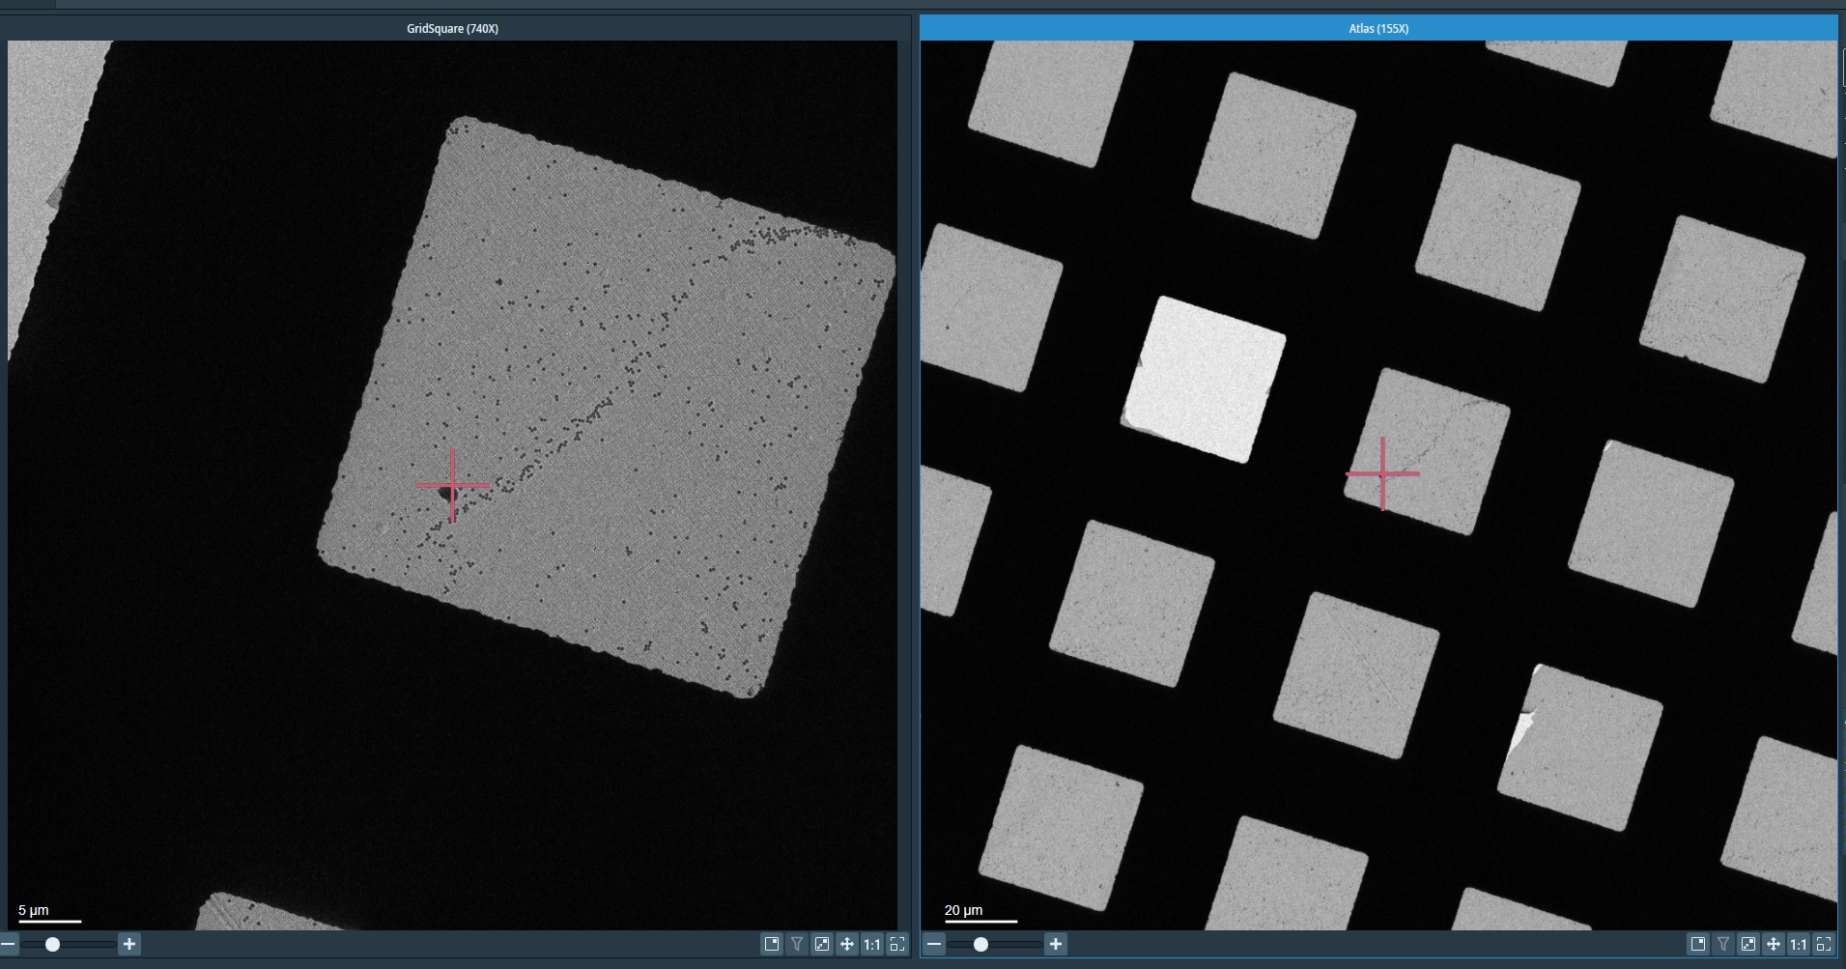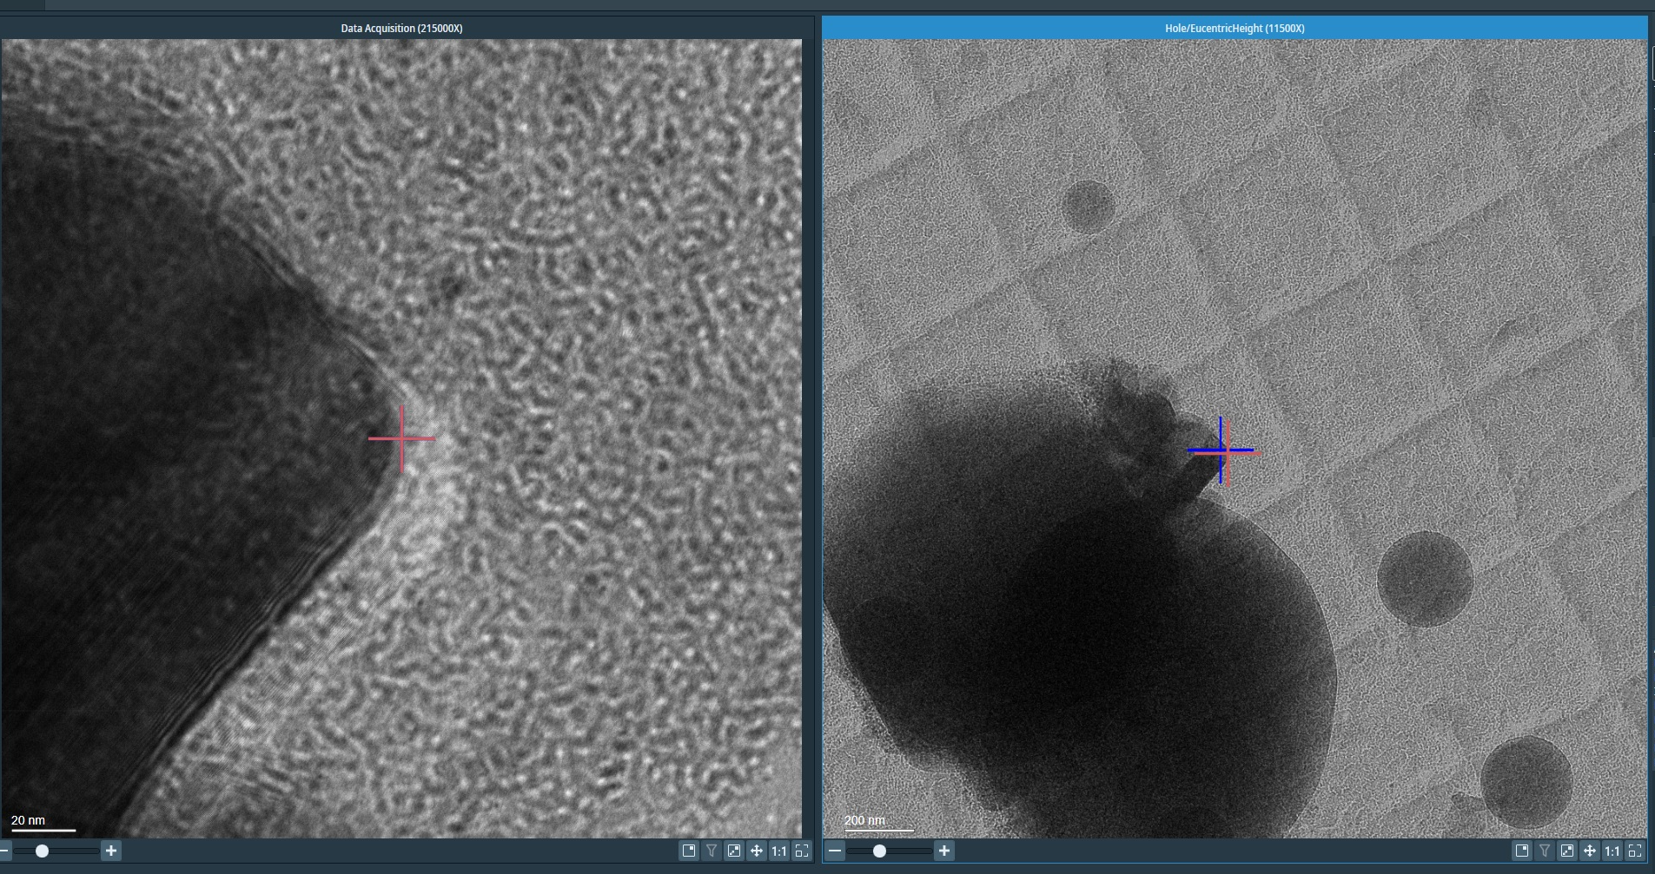
Atlas Acquisition
- Atlas tab > Session Setup Task > New Session > Yes
  - Session name: Lab_userinitials_date_Atlases_anything else that helps you (no spaces in names; this will make your life simpler when you are processing the data)
    - Example: Wolberger_CWH_20220731_Atlases_gridCWH50-53
  - Output folder: OffloadData > Lab > Personal
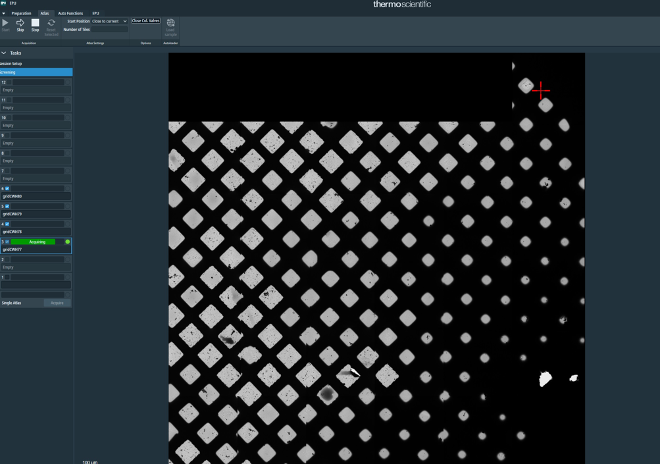
  - Format = mrc, then click apply
- Screening Task will appear with the inventoried grids available
- Check off grids you want to screen and click Start
  - Click Close column valves if it is not already selected. EPU will close the column valves at the end of the task as a precaution.

Setting up Collection
- After inspecting Atlases, select grid of interest and click Load Sample.
  - If you reloaded a grid, wait until you receive the measurement of sample displacement.
- EPU tab > Session creation > New session
  - Session name Lab_userinitials_date_gridID and anything else that helps you (no spaces in names)
    - Example: Wolberger_CWH_20220731_gridCWH50
  - Output folder: OffloadData > Lab > Personal
  - Format = mrc, session type manual, acquisition type faster
    - Faster enables AFIS (Aberration Free Image Shift), EPU’s routine for collecting multiple holes per stage movement using beam shift
    - If you really don’t want this efficiency, choose Accurate and it will collect one hole per stage movement
  - The EERs will automatically go in the OffloadData directory, in an automatically created folder that has the session name
- Square Selection Task
  - Unselect All (if you want, you could have preselected one of EPU’s color-coded set of squares in Atlas)
  - Right click and Select squares of interest (or hold down control and left click them)
  - Preferrable: select a few squares of different ice thickness to screen first with a few images. Proceed with hole selection and choose a few holes on each square for exposures. Once you are done screening, come back to this step to setup collection.
- Hole Selection Task
  - Click Acquire, it will go to square #1 first, etc
    - Check that the square is decently centered in that acquired image
  - Click Auto Eucentric
  - You should first Measure Hole Size, then Find Holes, then Remove Close to Grid Bar
    - If looking to simply screen grids and not collect data, add a few circles manually then click “Next Square”, “Auto-Eucentric”, and then select a few holes in this next square. Do this for all squares that you would like to screen through.
  - Use brush and shift or control click to remove or add, or adjust the ice thickness filter (learn this in person)
  - When satisfied with hole selection, click Prepare All Squares. It will automatically pick next square’s set of holes and automatically find its eucentric height.
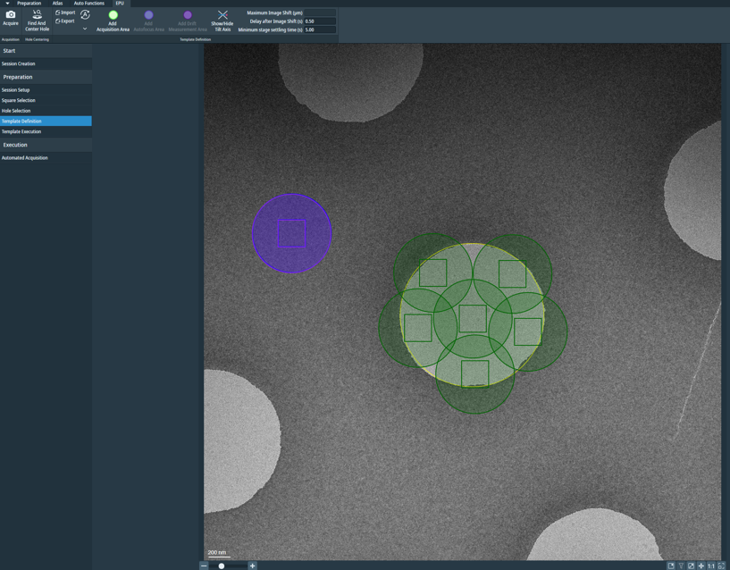
- Template Definition Task
  - Acquire and you’ll see a foil/hole level image (preferably with one complete hole and several fractional holes at the edges)
  - Add Acquisition Areas, Focus Area, Drift Measurement Areas
  - When clicked on an Acquisition Area, write a defocus list (negative values, comma-separated), with more of the values being close to focus
  - When clicked on the Focus Area, select the After Centering option (focuses once per stage movement)
  - When clicked on the Drift Measurement area, select once per square, 0.2 nm/s
  - Notes:
    - The green circle is the overall exposure area. The square within it is the detector. You can overlay exposure areas with each other, but you do not want to overlay the exposure area from one exposure into the camera detection area of another.
    - Blue is the autofocus area. Purple is the drift measurement area. Overlap these.
    - You need to provide a list of defoci for the collection. You must include the negative sign so that you are collecting under focus, and values need to be separated by commas. Anchor your collection with points closer to focus, then provide points further from focus
      - Make sure to copy defocus list to all acquisition areas (“paper stack” button).
    - For example: -0.3, 0.4, -0.5, -0.6, -0.7, -0.8, -1.0, -1.2, -1.4, -1.6
- Automated acquisition
  - Hit start
  - Close column valves on (button pressed in/turns dark) at end
- To save where you collected on your grid:
  - Navigate to square selection - Export image with grid selection

End of Day Checklist

- Samples put away
- LN2 levels checked
- Direct alignments done
- Gain reference current within two weeks
- Energy filter tuned, Auto Zero Loss Yes in EPU
- Turbo off (on the auto setting)
- Last few images are good
- Disk space checked
- Data transfer started
- Stage tilt 0
- “Closed Col. Calves” selected in EPU

Finished w/ Scope Checklist

- Close column valves
- Cross-grating on stage
- Insert screen
- Retract cameras
- Turbo on
- LN2 level check

